**Lab 24: Android Services using Kotlin**

# **Introduction**

**Android service** is a component that is *used to perform operations on the background* such as playing music, handle network transactions, interacting content providers etc. It doesn't has any UI (user interface). The service runs in the background indefinitely even if application is destroyed. The android.app.Service is subclass of ContextWrapper class.

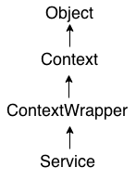

**Let’s get Started:**

In this experiment we will develop an Android App to demonstrate the use of Android Services.

**Step 1: Create a New Project in Android Studio as shown below**

**Step 2: Select Empty Activity as shown below**

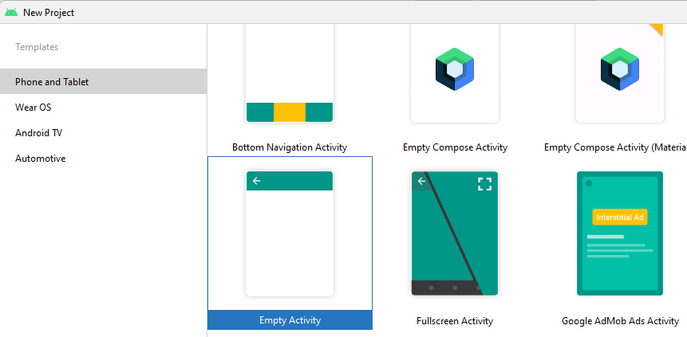

**Step 3: Provide a Project Name as shown below**

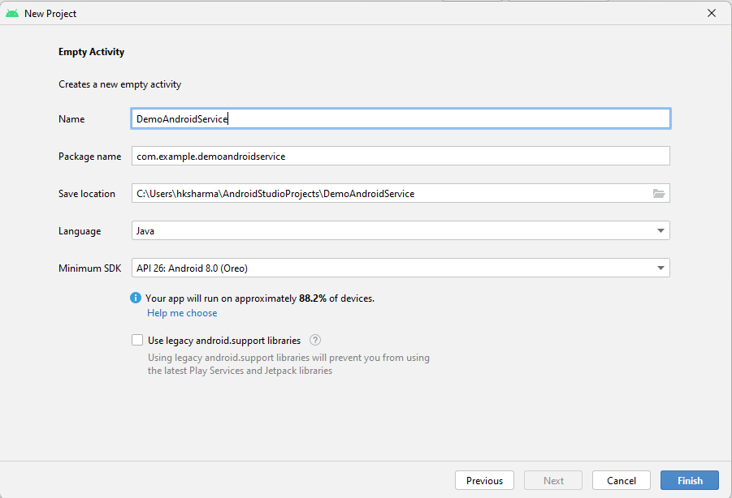

**Step 4: Update MainActivity.kt as per the code given below**

**package** com.example.kotlinservices  
**import** android.content.Intent  
**import** android.os.Bundle  
**import** android.view.View  
**import** android.widget.Button  
**import** androidx.appcompat.app.AppCompatActivity  
  
**class** MainActivity : AppCompatActivity(), View.OnClickListener {  
  
 *// declaring objects of Button class* **private var start**: Button? = **null  
 private var stop**: Button? = **null  
  
 override fun** onCreate(savedInstanceState: Bundle?) {  
 **super**.onCreate(savedInstanceState)  
 setContentView(R.layout.*activity_main*)  
  
 *// assigning ID of startButton  
 // to the object start* **start** = findViewById<View>(R.id.*startButton*) **as** Button  
  
 *// assigning ID of stopButton  
 // to the object stop* **stop** = findViewById<View>(R.id.*stopButton*) **as** Button  
  
 *// declaring listeners for the  
 // buttons to make them respond  
 // correctly according to the process* **start**!!.setOnClickListener(**this**)  
 **stop**!!.setOnClickListener(**this**)  
 }  
  
 **override fun** onClick(view: View) {  
  
 *// process to be performed  
 // if start button is clicked* **if** (view === **start**) {  
  
 *// starting the service* startService(Intent(**this**, NewService::**class**.*java*))  
 }  
  
 *// process to be performed  
 // if stop button is clicked* **else if** (view === **stop**) {  
  
 *// stopping the service* stopService(Intent(**this**, NewService::**class**.*java*))  
 }  
 }  
}

**Step 5: NewService.kt**

**package** com.example.kotlinservices  
**import** android.app.Service  
**import** android.content.Intent  
**import** android.media.MediaPlayer  
**import** android.os.IBinder  
**import** android.provider.Settings  
  
**class** NewService : Service() {  
  
 *// declaring object of MediaPlayer* **private lateinit var player**:MediaPlayer  
  
 *// execution of service will start  
 // on calling this method* **override fun** onStartCommand(intent: Intent, flags: Int, startId: Int): Int {  
  
 *// creating a media player which  
 // will play the audio of Default  
 // ringtone in android device* **player** = MediaPlayer.create(**this**, Settings.System.*DEFAULT_RINGTONE_URI*)  
  
 *// providing the boolean  
 // value as true to play  
 // the audio on loop* **player**.setLooping(**true**)  
  
 *// starting the process* **player**.start()  
  
 *// returns the status  
 // of the program* **return** *START_STICKY* }  
  
 *// execution of the service will  
 // stop on calling this method* **override fun** onDestroy() {  
 **super**.onDestroy()  
  
 *// stopping the process* **player**.stop()  
 }  
  
 **override fun** onBind(intent: Intent): IBinder? {  
 **return null** }  
}

**Step 6: activity_mail.xml**

*<?***xml version="1.0" encoding="utf-8"***?>*<**androidx.constraintlayout.widget.ConstraintLayout  
 xmlns:android="http://schemas.android.com/apk/res/android"  
 xmlns:app="http://schemas.android.com/apk/res-auto"  
 xmlns:tools="http://schemas.android.com/tools"  
 android:layout_width="match_parent"  
 android:layout_height="match_parent"  
 android:background="#168BC34A"  
 tools:context=".MainActivity"**>  
  
 <**LinearLayout  
 android:id="@+id/linearLayout"  
 android:layout_width="match_parent"  
 android:layout_height="wrap_content"  
 android:layout_centerVertical="true"  
 android:orientation="vertical"  
 app:layout_constraintBottom_toBottomOf="parent"  
 app:layout_constraintEnd_toEndOf="parent"  
 app:layout_constraintStart_toStartOf="parent"  
 app:layout_constraintTop_toTopOf="parent"  
 app:layout_constraintVertical_bias="1.0"  
 tools:ignore="MissingConstraints"**>  
  
 <**TextView  
 android:id="@+id/textView1"  
 android:layout_width="match_parent"  
 android:layout_height="wrap_content"  
 android:layout_marginBottom="170dp"  
 android:text="@string/heading"  
 android:textAlignment="center"  
 android:textAppearance="@style/TextAppearance.AppCompat.Large"  
 android:textColor="@android:color/holo_green_dark"  
 android:textSize="36sp"  
 android:textStyle="bold"** />  
  
 <**Button  
 android:id="@+id/startButton"  
 android:layout_width="match_parent"  
 android:layout_height="match_parent"  
 android:layout_marginStart="20dp"  
 android:layout_marginTop="10dp"  
 android:layout_marginEnd="20dp"  
 android:layout_marginBottom="20dp"  
 android:background="#4CAF50"  
 android:text="Start the Service"  
 android:textAlignment="center"  
 android:textAppearance="@style/TextAppearance.AppCompat.Display1"  
 android:textColor="#FFFFFF"  
 android:textStyle="bold"** />  
  
 <**Button  
 android:id="@+id/stopButton"  
 android:layout_width="match_parent"  
 android:layout_height="match_parent"  
 android:layout_marginStart="20dp"  
 android:layout_marginTop="10dp"  
 android:layout_marginEnd="20dp"  
 android:layout_marginBottom="20dp"  
 android:background="#4CAF50"  
 android:text="Stop the Service"  
 android:textAlignment="center"  
 android:textAppearance="@style/TextAppearance.AppCompat.Display1"  
 android:textColor="#FFFFFF"  
 android:textStyle="bold"** />  
  
 <**ImageView  
 android:id="@+id/imageView"  
 android:layout_width="match_parent"  
 android:layout_height="wrap_content"  
 android:layout_marginTop="80dp"** />  
 </**LinearLayout**>  
  
</**androidx.constraintlayout.widget.ConstraintLayout**>

**Step 7:AndroidManilfest.xml**

*<?***xml version="1.0" encoding="utf-8"***?>*<**manifest xmlns:android="http://schemas.android.com/apk/res/android"  
 xmlns:tools="http://schemas.android.com/tools"  
 package="com.example.kotlinservices"**>  
  
 <**application  
 android:allowBackup="true"  
 android:dataExtractionRules="@xml/data_extraction_rules"  
 android:fullBackupContent="@xml/backup_rules"  
 android:icon="@mipmap/ic_launcher"  
 android:label="@string/app_name"  
 android:roundIcon="@mipmap/ic_launcher_round"  
 android:supportsRtl="true"  
 android:theme="@style/Theme.KotlinServices"  
 tools:targetApi="31"**>  
 <**service  
 android:name=".NewService"  
 android:enabled="true"  
 android:exported="true"**></**service**>  
  
 <**activity  
 android:name=".MainActivity"  
 android:exported="true"**>  
 <**intent-filter**>  
 <**action android:name="android.intent.action.MAIN"** />  
  
 <**category android:name="android.intent.category.LAUNCHER"** />  
 </**intent-filter**>  
  
 <**meta-data  
 android:name="android.app.lib_name"  
 android:value=""** />  
 </**activity**>  
  
 </**application**>  
  
</**manifest**>

**Step 7: Check Output on Android Emulator and it should look like as given below**

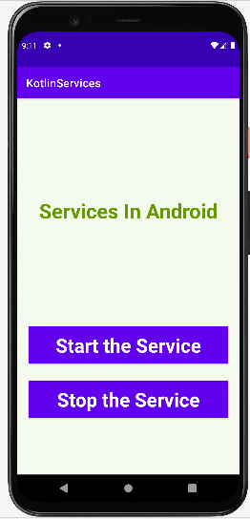

**Voila!!** We have successfully completed this lab.